

**Project Report**

**OF**

**Frontend Engineer**

**CS156**

**Submitted By Submitted To**

Adish Singla

2110990077

Dr. **Pritpal Kaur**

### Department of Computer Science & Engineering Chitkara University Institute of Engineering & Technology,

**Rajpura, Punjab.**

**Introduction to TO-Do Lists:**

A to-do list is a tool that individuals use to record, organize, and prioritize tasks that they need to accomplish within a specific timeframe. It serves as a simple and effective method for managing daily activities, projects, or goals. The primary purpose of a to-do list is to help individuals stay organized, focused, and productive by providing a clear overview of tasks and their status.

Key features of a to-do list include:

1. Task Entry: Users can add tasks, activities, or goals to the list. These items can range from work-related assignments to personal chores.

2. Organization: Tasks can be organized based on different criteria such as project, priority, due date, or category, making it easier to manage and categorize them effectively.

3. Prioritization: Users can assign priorities to tasks, distinguishing between those that are urgent, important, or less time-sensitive.

4. Status Tracking: To-do lists often include checkboxes or other indicators to mark tasks as completed, providing a visual representation of progress.

5. Time Management: Some to-do lists include the option to schedule tasks for specific times or allocate time slots, aiding in time management and planning.

6. Collaboration: In team or collaborative settings, to-do lists can be shared among group members, facilitating coordination and communication.

To-do lists can be created using various tools, including traditional pen and paper, digital applications, or specialized project management software. The flexibility and simplicity of to-do lists make them widely used in both professional and personal contexts to enhance organization and productivity.

**Benefits of To-Do Lists:**

Using a to-do list can offer a wide range of benefits, both for individuals and teams, in terms of organization, productivity, and overall well-being. Here are some key benefits of using a to-do list:

1. Organization:

- Centralized Task Management: A to-do list provides a single, organized space for listing and managing tasks, reducing the likelihood of forgetting important activities.

2. Prioritization:

- Task Prioritization: Allows users to prioritize tasks based on urgency or importance, helping them focus on what needs to be done first.

3. Increased Productivity:

- Focus and Efficiency: By breaking down larger tasks into smaller, manageable steps, a to-do list promotes focus and increases efficiency in completing tasks.

Function Used:

**It seems like you've built a functional React component for managing a to-do list (`TodoWrapper`). Let's break down the key features:**

**1. State Management:**

**- The `todos` state is managed using the `use State` hook, storing an array of tasks.**

**2. Todo Management Functions:**

**- `add Todo`: Adds a new task to the `todos` state using the spread operator to preserve the existing tasks.**

**- `delete Todo`: Removes a task from the `todos` state based on its ID.**

**- `toggle Complete`: Toggles the completion status of a task in the `todos` state.**

**- `edit Todo`: Toggles the editing status of a task in the `todos` state.**

**- `edit Task`: Edits the content of a task and toggles the editing status in the `todos` state.**

**3. Rendering:**

**- Renders a `TodoForm` component for adding new tasks.**

**- Maps over the `todos` array and renders either an `EditTodoForm` or a `Todo` component based on the `isEditing` status of each task.**

**4. Components Used:**

**- It references other components such as `TodoForm`, `EditTodoForm`, and `Todo`. The functionality of these components isn't provided in the code snippet, but they seem to handle form submissions, editing, and rendering individual tasks.**

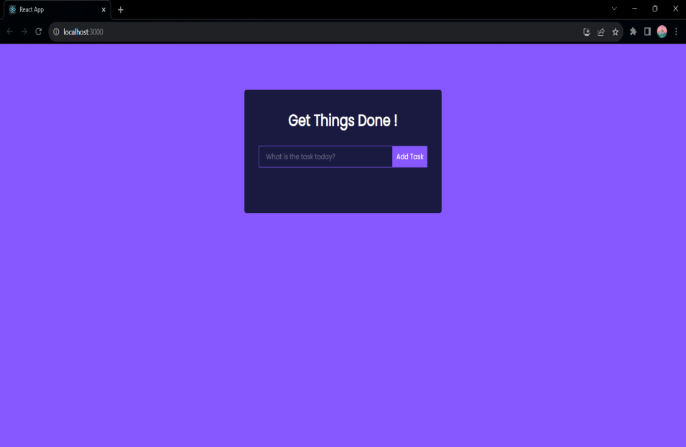

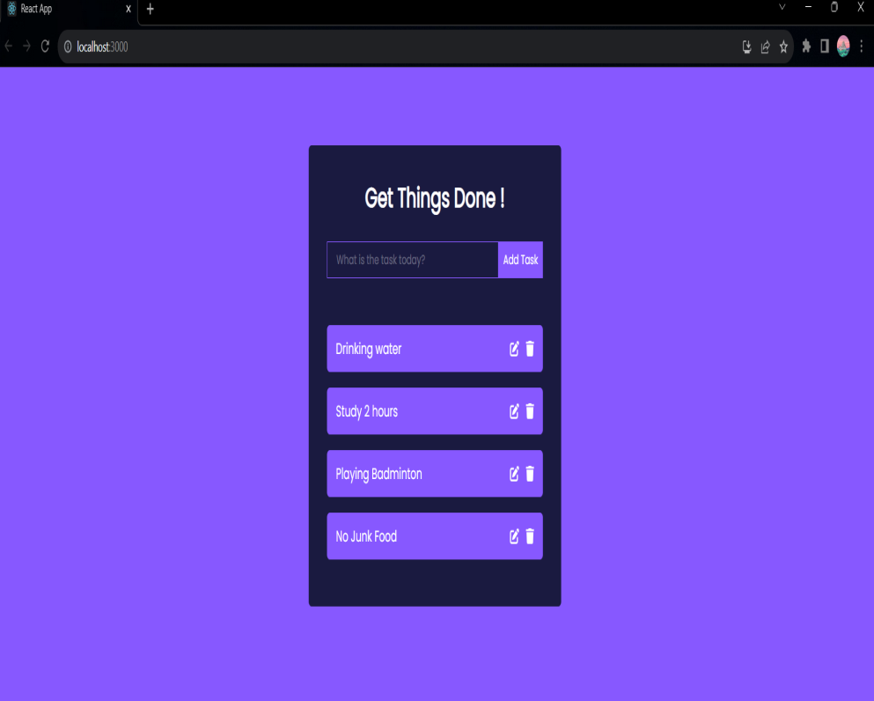

**Conclusion:**

In conclusion, a to-do list is a powerful and versatile tool that significantly contributes to personal and professional productivity. By providing a structured framework for organizing tasks, a to-do list offers numerous benefits that enhance efficiency, reduce stress, and promote goal achievement. The simplicity and flexibility of to-do lists make them widely adopted across various contexts.

Incorporating a to-do list into daily routines empowers individuals to take control of their tasks, manage their time effectively, and work towards their goals with clarity. Whether it's a handwritten list, a digital application, or part of a larger project management system, the to-do list remains a fundamental tool for success.

In the ever-evolving landscape of work and personal responsibilities, the to-do list stands as a reliable companion, helping individuals navigate the complexities of their daily lives and work towards a more organized, productive, and fulfilling future.